PROCESS-CONTROLLED MACHINING OF GRAY CAST
IRON

A SEMINAR REPORT
Submitted by

SADIQU P

Reg.No: MEA16ME093

to

the APJ Abdul Kalam Technological University
in partial fulfilment of the requirements for the award of the Degree
of
Bachelor of Technology
In
Mechanical Engineering

Department of Mechanical Engineering
MEA Engineering College
Perinthalmanna
November,2019

DECLARATION

I undersigned hereby declare that the seminar report “PROCESS-CONTROLLED MACHINING OF GRAY CAST IRON”, submitted for partial fulfilment of the requirements for the award of Bachelor of Technology of the APJ Abdul Kalam Technological University, Kerala is a bonafide work done by me under supervision of Mr.NOUSHADAssistant professor in Mechanical Engineering. This submission represents my ideas in my own words and where ideas or words of others have been included, I have adequately and accurately cited and referenced the original sources. I also declare that I have adhered to ethics of academic honesty and integrity and have not misrepresented or fabricated any data or idea or fact or source in my submission. I understand that any violation of the above will be a cause for disciplinary action by the institute or the University and can also evoke penal action from the sources which have thus not been properly cited or from whom proper permission has not been obtained. This report has not been previously formed the basis for the award of any degree, diploma or similar title of any other University.

Place: Perinthalmanna SADIQU P
Date:

DEPARTMENT OF MECHANICAL ENGINEERING
MEA ENGINEERING COLLEGE, PERINTHALMANNA



CERTIFICATE

This is to certify that the report entitled ‘PROCESS-CONTROLLED MACHINING OF GRAY CAST IRON’ submitted by SADIQU.P.(MEA16ME093) to the APJ Abdul Kalam Technological University in partial fulfilment for the award of the Degree of Bachelor of Technology in Mechanical Engineering is a bonafide record of the seminar work carried out by him under my guidance and supervision. This report in any form has not been submitted to any other University or Institute for any purpose.
Supervisor: Seminar Coordinator:  Mr Noushad T.T Mr.Shafeeque  Assistant Professor Assistant Proffessor  Mechanical Dept. Mechanical Dept. | Head of the department:  Dr.Mubarak M.  Associate Professor  Mechanical Dept.

ACKNOWLEDGEMENT

I express my deep and sincere gratitude to my guide, Mr.NOUSHAD.T.T., Assistant Professor, Department of Mechanical Engineering, for the kind co-operation and guidance for the completion of my seminar.
I express my sincere gratitude to Dr. G. RAMESH, our respected principal for giving us an opportunity and for the facilities provided for the completion of my seminar.
I express our deepest sense of gratitude to our Head of Department of Mechanical Engineering Dr.Mubarak .M., Associate Professor, MEA Engineering College,
Perinthalmanna for his valuable support and guidance.
I also extend my gratitude to Staff in Charge Mr.SHAFEEQUE., Associate Professor, Department of MechanicalEngineering,Mr.SWALIH., Assistant Professor, Department of Mechanical Engineering, for their kind co-operation for preparing and presenting this seminar.
I also express my sincere thanks to all staff members of Mechanical Department for their kind co-operation they have rendered.
I thankfully acknowledge my parents, my friends and all others for their support and encouragement.

SADIQU P

ABSTRACT

A model to predict surface roughness for specified values of cutting tool nose radius, feed rate, cutting speed and tool wear. The model isbased on experimental data from finish turning of gray cast iron using uncoated tungstencarbide inserts. The results suggest that feed rate and cutting speed can be modified toproduce a specified surface roughness in the presence of increasing levels of tool wear.The method used in the paper to calculate values of feed rate and cutting speed isbased on a multiple objective goal programming optimization scheme. The methodpredicts optimal machining conditions under the conflicting objectives of maximal production rate and minimal cost, subject to realistic constraints imposed by the capability of the machine tool and restrictions on the process parameters. Further adjustment of the cutting parameters is then made based on specified values of surfaceroughness and levelsBefore describing the method used to calculate the best feed and speed, a summaryof the model used to characterize surface roughness will be presented. While thespecific equation and the interpretation are derived from machining tests on gray castiron, the overall concept can be applied to other machining operations.

 |  | CONTENTS
Chapter No: |  | TITLE PAGE
 |  | ACKNOWLEDGEMENT i
 |  | ABSTRACT ii
 |  | LIST OF FIGURES iv
1 |  | INTRODUCTION 1
2 |  | MACHINING 2
3  4 |  | 2.1.Introduction 2  2.2.History and terminology 2  2.3.Machining operations 3  2.4.Overview of machining operations 4  2.5.Cutting tool 4  2.6.Stages in metal cutting 5  CONTROL OF MACHINING OPERATIONS  3.1.Introduction 5  3.2.Background 5  3.3.Types of controlled machining 6  3.4.Servo control 7  3.5.Process control 7  3.6.Supervisory control 8  PROCESS CONTROLLED MACHINING
 |  | 4.1.Introduction 9
5  6 |  | SURFACE ROUGHNESS IN TURNING 10  5.1.Introduction 10  MACHINABILTY DATA OPTIMIZATION 12
6.1.Data optimization 12
6.2.Goal programming for multiple objectives 13

7 |  | ADJUSTMENT OF CUTTING PARAMETERS 15
 |  | 7.1.Adjusting cutting parameters 15
8 |  | SUMMARY 16
9 |  | REFERENCES 17
LIST OF FIGURES

FIG.NO. NAME OF FIGURES PAGE

1 Types of controlled machining 6

2 Computer vision system 7
 |  | 3 Surface roughness 11
 |  | 4 Machinability data optimization 12
 |  | 5 Adjustment of cutting parameters 16

Chapter 1

INTRODUCTION

Increasing the cutting speed, feed rate and/or depth of cut in a turning operation increases the metal removal rate, and hence the production rate. But such increases result in increased levels of tool wear, more frequent tool changes, and correspondinglyincreased production cost. Theoretically, optimal values of cutting speed and feed ratedo exist that can trade off the production and/or business objectives, while keeping theoperations within the machine tool's capability. Performance objectives that have beenproposed for machining operations include maximal production rate, mimimal cost (e.g.,directlabor, machining, or total manufacturing), maximal metal removal rate, maximalprofit, and others. Usually only one criterion is actually used or possibly an "averaging"of more than one is used. A more meaningful methodology will determine the cuttingparameters that most closely meet several stated objectives.An added complexity to the problem comes from the desire to achieve specifiedvalues of surface roughness and tolerance for the parts. Since surface roughness isaffected by the cutting parameters and by the amount of tool wear present, a methodwhich will predict optimal operating parameters must consider the part requirementsand the process conditions, in addition to the production objectives.The selection of the "best" cutting parameters for machining operations is done in avariety of ways and produces varied results. Probably the most common method toselect the parameters is based on current practice. Either the machinist or the engineeruses certain "rules of thumb." Another way to determine the parameters is to usehandbooks or other published guides. More recently, computer-based methods havebecome available which either automate the table look-up process or use mathematicalformulae. Each method has inherent advantages and limitations.

Chapter 2
MACHINING

2.1 Introduction

Machining is any of various processes inwhich a piece of raw material is cut into adesired final shape and size by acontrolled material-removal process. Theprocesses that have this common theme, controlled material removal, are today collectively known as subtractive manufacturing, in distinction from processes of controlled material addition, which are known as additivemanufacturing. Exactly what the controlled" part of the definition implies can vary, but it almost always implies theuse of machine tools (in addition to just power tools and hand tools).Machining is a part of the manufacture of many metal products, but it can also beused on materials such as wood, plastic, ceramic, and composites.[2] A person whospecializes in machining is called amachinist. A room, building, or company where machining is done is called amachine shop. Much of modern-daymachining is carried out by computernumerical control (CNC), in whichcomputers are used to control themovement and operation of the mills, lathes, and other cutting machines.

2.2History and terminology

The precise meaning of the term machining has evolved over the past oneand a half centuries as technology hasadvanced. In the 18th century, the word machinist simply meant a person who builtor repaired machines. This person's workwas done mostly by hand, using processes such as the carving of wood and the handforgingand hand-filing of metal. At thetime, millwrights and builders of new kinds of engines (meaning, more or less, machines of any kind), such as James Watt or John Wilkinson, would fit thedefinition. The noun machine tool and machine (machined, machining) did not yet exist .A round the middle of the 19th century, the latter words were coined as the conceptsthat they described evolved into widespread existence. Therefore, during the Machine Age, machining referred to(what we today might call) the "traditional"machining processes, such as turning,boring, drilling, milling, broaching, sawing,shaping, planing, reaming, and tapping.[3]In these "traditional" or "conventional"machining processes, machine tools, such as lathes, milling machines, drill presses,or others, are used with a sharp cutting tool to remove material to achieve a
desired geometry.

  - .Machining operations

The three principal machining processesare classified as turning, drilling andmilling Turning operations are operations that rotate the workpiece as the primary method of moving metal against thecutting tool. Lathes are the principalmachine tool used in turning.Milling operations are operations inwhich the cutting tool rotates to bringcutting edges to bear against the workpiece. Milling machines are theprincipal machine tool used in milling.Drilling operations are operations inwhich holes are produced or refined bybringing a rotating cutter with cuttingedges at the lower extremity into contact with the workpiece. Drilling operations are done primarily in drill presses but sometimes on lathes or mills .Miscellaneous operations are operations that strictly speaking maynot be machining operations in that theymay not be swarf producing operations but these operations are performed at atypical machine tool. Burnishing is anexample of a miscellaneous operation.Burnishing produces no swarf but canbe performed at a lathe, mill, or drill press.An unfinished workpiece requiring machining will need to have some materialcut away to create a finished product. Afinished product would be a workpiece that meets the specifications set out for that workpiece by engineering drawings orblueprints. For example, a workpiece maybe required to have a specific outsidediameter. A lathe is a machine tool thatcan be used to create that diameter by rotating a metal workpiece, so that a cutting tool can cut metal away, creatingsmooth, round surface matching therequired diameter and surface finish. Adrill can be used to remove metal in theshape of a cylindrical hole. Other tools thatmay be used for various types of metalremoval are milling machines, saws, andgrinding machines. Many of these sametechniques are used in wood working.More recent, advanced machining techniques include precision CNC machining, electrical discharge machining(EDM), electro-chemical erosion, lasercutting, or water jet cutting to shape metal workpieces.[6]As a commercial venture, machining isgenerally performed in a machine shop, which consists of one or more workroomscontaining major machine tools. Although a machine shop can be a stand-aloneoperation, many businesses maintaininternal machine shops which supportspecialized needs of the business.Machining requires attention to many details for a workpiece to meet the specifications set out in the engineering drawings or blueprints. Beside the obviousproblems related to correct dimensions,there is the problem of achieving thecorrect finish or surface smoothness on the workpiece.

2.4.Overview of machining technology

Machining is any process in which acutting tool is used to remove small chipsof material from the workpiece (theworkpiece is often called the "work"). Toperform the operation, relative motion isrequired between the tool and the work.This relative motion is achieved in mostmachining operation by means of aprimary motion, called "cutting speed" anda secondary motion called "feed".[7] Theshape of the tool and its penetration intothe work surface, combined with thesemotions, produce the desired shape of theresulting work surface.

  - .Cutting tool

A cutting tool has one or more sharpcutting edges and is made of a material that is harder than the work material. Thecutting edge serves to separate chip fromthe parent work material. Connected to thecutting edge are the two surfaces of the tool:The rake face; and The flank.The rake face which directs the flow of newly formed chip, is oriented at a certainangle is called the rake angle "α". It is measured relative to the plane perpendicular to the work surface. Therake angle can be positive or negative. The flank of the tool provides a clearancebetween the tool and the newly formedwork surface, thus protecting the surfacefrom abrasion, which would degrade thefinish. This angle between the worksurface and the flank surface is called therelief angle. There are two basic types of cutting tools: Single point tool; and Multiple-cutting-edge tool A single point tool has one cutting edgeand is used for turning, boring and planing. During machining, the point of the toolpenetrates below the original work surfaceof the workpart. The point is sometimesrounded to a certain radius, called the nose radius. Multiple-cutting-edge tools have more thanone cutting edge and usually achieve theirmotion relative to the work part by rotating. Drilling and milling uses rotating multiplecutting-edge tools. Although the shapes ofthese tools are different from a singlepointtool, many elements of toolgeometry are similar.

2.5 Stages in metal cutting

Machining operations usually divide intotwo categories, distinguished by purposeand cutting conditions: roughing cutsFinishing cutsRoughing cuts are used to remove largeamount of material from the startingworkpart as rapidly as possible, i.e. with alarge Material Removal Rate (MRR), inorder to produce a shape close to thedesired form, but leaving some material onthe piece for a subsequent finishingoperation. Finishing cuts are used tocomplete the part and achieve the finaldimension, tolerances, and surface finish.

Chapter 3

Control of Machining Processes

3.1 Introduction

Machining, or metal removal, processes are widely used In,manufacturing and include operations such as turning, milling,drilling, and grinding. The push toward automation in machininghas been driven by the need to maintain high productquality while improving production rates.In addition to predicting the optimal parameters to begin the cutting process, theapproach also used in this research considers a specified surface roughness, even in the presence of increasing tool wear. The net result is a strategy that assures the greatest utilization of the assigned resources consistent with the specified performan criteria..The research results also can be incorporated into a process adjustment strategy .By appropriately adjusting, not only the tool offset position, but also the feed and cuttingspeed, it becomes possible to meet both dimensional and surface roughnessspecifications. While some preliminary work has been done on this concept.

3.2 Background

Machining operations date back to the 18th century, and represent a mature technology. However, therehave beenmany improvements in machines, cutting tools, andmaterials that have led to significant benefits. One of the mostimportant developments has been the introduction of automationduring the past three to four decades. In the 1950s•numerically controlled (NC) machine tools were developedunder an Air Force contract to Parson's Machine Tool Company(Traverse City, Michigan) by the Servomechanisms Laboratoryat MIT. These reprogrammable but hard-wired digitaldevices represented the state-of-the-art into the 1960s. Duringthe 1960s and 1970s, both computer technology and NC machinetools continued to evolve. Computers became not onlymore powerful, but also less expensive and more reliable. Theservo-control function (including interpolators for multiaxiscoordination) became implemented using on-board computers.

3.3 Types of controlled machining
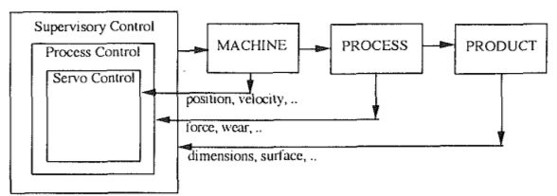

Fig.1:Types of controlled machining
Figure 1 schematically illustrates a convenient classification for the different levels of control that one might encounter in a controller for a machining process. The lowest level is servo control, where the motion of the cutting tool relative to the workpiece is controlled. Next is a process control level, where process variables such as cutting forces and tool wear are controlled to maintain high production rates and good part quality. Finally, the highest level is a supervisory one whichdirectly measures product-related variables, such as part dimensions and surface roughness. The supervisory level also performs functions such as chatter detection, tool monitoring, machine monitoring, etc.

3.3 Servo Control

The servo level controllers can be classifiedinto two cases: (0 point-to-point (PTP), and (ii) contouring.In a PTP system, the controller moves the tool to a required position where the process operation is performed. The trajectory between the points is not controlled. Point-to-point control is required in applications like drilling and spot welding,and is the simpler of the two cases. It has much in common with PTP servo control problems in other application areas ,such as robotics. However, the PTP control problem in manufacturing does have some special considerations which arise from the high accuracy requirements (e.g., 0.01 mm or better)and the interactions between the machine tool and the process, as shown in Fig. 2. For example, cutting forces and heat generated during the process must be considered to ensure accuracy in the PTP problem. The machine tool geometric errors affect PTP positioning accuracy, and are of several types: (i) volumetric errors due to slight irregularities in the components of the machine structure, (if) volumetric errors due to the machine thermal effects, and (iif) volumetric errors due to the effects of cutting forces. The first type can be compensated for, based upon off-line measurements (and modeling) of the machine geometric errors by technologies such as laser interferometry

However, the second and third type require on-line compensation ,typically based upon temperature and/or force measurements and models relating these measured variables to geometric errors in each axis of the machine tool. Typically, minimum variance, forecasting, or predictive control approaches.
3.4 Process Control

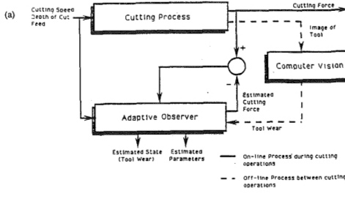
Fig.2:Computer vision system
Successful implementation at the process control and supervisory levels requires realistic process modeling based upon a good physical understanding of the processto be controlled. The measured output is the cutting force, and is used in conjunction with the model to estimate the state of wear of the tool. The difficulties in implementing this approach are due to the nonlinearnature ofthe process model and variation of the model parameters.Earlier attempts using a linear adaptive state observer wereonly partially successful. it is not sufficiently accurate for compensation of geometric errors due to tool wear.A more accurate, and flexible, tool wear monitoring systemcan be developed by combining the force measurement basedadaptive observer with direct optical measurement of the toolwear using a computer vision system. The vision system is very accurate,but can only be used between parts when the tool is not in contact with the workpiece. The force-based adaptive observerbe used during cutting. By intermittently (i.e., between parts) recalibrating the adaptive observer using the vision system,a very accurate estimate of tool wear can be obtainedeven under large variations in the cutting conditions. Experimentalresults, shown are from laboratory turningtests with large stepwise changes in the feedrate. The solid lineis the tool wear estimate, the circles are the vision measurementsused to recalibrate the observer, and the x's are the wear valuesmeasured using a tool maker's microscope. Errors in the flankwear estimate are less than 50 nm (2x 10"~3 in) over the entirecutting period, and improve as the cutting proceeds toward the end of the tool life.
The basic problem arises from the fact that the effective process gains and time constants depend upon process variables such as feed,speed, and depth-of-cut. Furthermore, process related parameters such as tool geometry, work, and tool material properties are difficult to characterize and can have a significant effect on the process dynamics. This unpredictability of the process can lead to poor performance, tool breakage, or even in stability when fixed gain process controllers are used (Masory and Koren,1980, 1985). These problems, due to process model uncertainty,were a primary reason for the poor industrial acceptance of the first generation of AC systems for machining.To address this problem, adaptive control schemes, combining on-line parameter estimation and control, were developed and applied to machining processes.

3.5 Supervisory control

The supervisory level is the area thathas received the least research attention to date, and can beexpected to be a major focus of future research. There are in\fact many levels of control in a machining process controlhierarchy, and what we have referred to here as supervisorycontrol includes functions such as selection of control strategies. For example, knowledge of the part geometry as contained in the CAD system can be used to determine the referencevalues of process variables. Furthermore, the supervisory level can monitor for tool and/or machine failures or degradation .Process related phenomena, such as chatter and chip,can also be monitored. Information from various process related sensors can be integrated to improve the reliability and quality of sensor information. Finally, all of thisinformation can be used to achieve on-line optimization of themachining process.

As an example of supervisory control in machining, consider a through-hole drilling operation. A successful control strategymust ensure good hole quality, prevent drill breakage, minimizeburr formation at the exit, and also maintain high metalremoval rates. A strategy which achieves these goals, basedupon process optimization methods, is described in Furness(1992). The control system includes a servo control level wherethe spindle speed and the drill feed rate are accurately controlled.A process control level implements a torque controllerto prevent drill breakage. The supervisory controller, based upon the drill position (depth-of-hole), selects an appropriatestrategy for use at the process control level as well as the appropriate reference signals for that strategy. Specifically,the supervisory level selects a feed and speed control strategy at the entrance phase based upon hole quality (hole location error) considerations. The feed and speed references are selected based upon the required hole location error constraint .After the hole is initiated, the supervisory controller switchesto a speed and torque control strategy with the reference values determined from tool breakage and tool wear considerations .Finally, as the operation nears drill breakthrough, the supervisory controller switches back to a feed and speed control strategy to minimize burr formation. Thus, the supervisory controller selects control strategies and their associated referencelevels for optimization of the drilling process.

CHAPTER 4
PROCESS CONTROLLED MACHINING
4.1.Inroduction
Increasing the cutting speed, feed rate and/or depth of cut in a turning operationincreases the metal removal rate, and hence the production rate. But such increasesresult in increased levels of tool wear, more frequent tool changes, and correspondinglyincreased production cost. Theoretically, optimal values of cutting speed and feed ratedo exist that can trade off the production and/or business objectives, while keeping theoperations within the machine tool's capability. Performance objectives that have beenproposed for machining operations include maximal production rate, mimimal cost (e.g.,direct labor, machining, or total manufacturing), maximal metal removal rate, maximalprofit, and others. Usually only one criterion is actually used or possibly an "averaging"of more than one is used. A more meaningful methodology will determine the cuttingparameters that most closely meet several stated objectives.An added complexity to the problem comes from the desire to achieve specifiedvalues of surface roughness and tolerance for the parts. Since surface roughness isaffected by the cutting parameters and by the amount of tool wear present, a methodwhich will predict optimal operating parameters must consider the part requirementsand the process conditions, in addition to the production objectives.

CHAPTER 5

SURFACE ROUGHNESS IN TURNING

5.1.Surface roughness

The theoretical model for surface roughness generally used in machiningcalculations is based on the fact that the tool geometry is being reproduced on the worksurface in the form of feed marks, provided the cutting speed selected gives continuouschips with no built-up edge.Regardless of built-up edge formation, the fact that the tool wears as cutting takes place means that the tool geometry, i.e., nose radius or clearance angle, may change which will alter the feed marks produced on the work surface. The theoretical surface roughness model fails to account for the changes taking place with tool wear.While there are a number of parameters used to represent surface roughness, themost often used and the one that is used in this paper is the roughness average shows a simple representation of the roughness average.
The theoretical model for surface roughness has been treated extensively. In applying the theoretical model to a finish turning operation, the followingassumptions are made:
(i) The nose radius of the tool is at least 3 to 4 times the feed rate.
(ii) The cutting speed used produces continuous chips and avoids built-up
edge formation.
(iii) The depth of cut is small, i.e., cutting takes place with the tool nose.
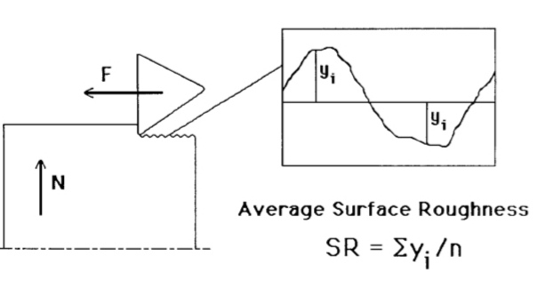
Wall bank says that even under the conditions assumed by the theoreticalmodel, tool wear causes distortion of the feed marks and roughness between the feedmarks. The size, shape and distribution of roughness between feed marks depends onthe work material and wear on the tool. Domtamsetti and Fischer (ref. 1) show a comparison of the theoretical model forsurface roughness and their model, which accounts for the effects of tool wear, noseradius, cutting speed and feed rate. It is clear from this work that the theoretical mode is in adequate, even for the condition of no tool wear. It must be kept in mind that the Dontamsetti model was derived from data obtained while finish turning gray cast iron with a tungsten carbide cutting tool. Further, it appears that the fracture mechanism of gray cast iron tends to cause greater surface roughness than would be seen in a moreuniform material such as steel turned under comparable conditions.The surface roughness model provides a way to determine how the feed and speed should be adjusted to compensate for tool wear. In
Fig.3:Surface roughness
general, it is observed that three types of response are possible. For low feed and speed, roughness increases as tool wear increases. For moderate feed and speed, roughness remains relatively constant as tool wear increases. For high feed and speed, roughness actually reduces as tool wear increases. The values of feed and speed that are calculated to proviae the best performance can be tested in the surface roughness model to determine; if a specified design requirement can be met. The difficulty that remains is deciding which combination of cutting speeds aria feed rates to select to begin the finishing operation and what is the best strategy for adjusting the cutting parameters while the cutting toot wears. This is where the goal programming methodology is helpful.

CHAPTER 6
MACHINABILITY DATA OPTIMIZATION

6.1.Data optimization

As mentioned earlier, satisfying a single optimal objective may not be sufficient. Therefore, the use of a multiple objective optimization may be needed to determine the best cutting parameters. The objectives may be conflicting, that is, the parameters that are found to be optimum for one objective may not be optimal for another objective Fig 2 shows the "classical" conflict between trying to find a cutting speed that will minimize the production cost and at the same time maximize production rate. The objectives o, ~ maximal production rate and minimal production cost, subject to realistic machine and process constraints have been selected.
An optimization problem with the cost and production rate objectives can be expressed as follows: Minimize fl(x,y) and maximize f2(x,y) Subject to gl(x,y) -< 0
gn(x,y) -< 0 where fl and f2 represent minimal production cost and maximal production rate, respectively. Because fl and f2 are conflicting, any solution must have some level of compromise between the two functions.
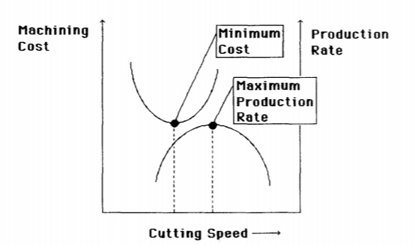
Fig.4:Machinability data optimization

6.2.Goal programming for multiple objectives

Goal programming is an effective method to deal with multiple conflicting objectives, subject to complex environmental constraints. Goal programming can handle decision problems that involve either a single goal or multiple goals. The approach uses an ordinal hierarchy among conflicting multiple objectives so that the tow-order goals are considered only after the higher-order objectives are satisfied or have reached the desired limit. A simple example illustrates how to transform goals into goal constraints. Consider the equation, ax + by = 10 (2) where a and b are certain constants. Suppose you are to find all values of both variables x and y that satisfy eqn. 2. If a second equation for x and y can not be found, an approximation method can be developed. The problem can be reformulated to include both positive and negative deviations from the desired solution, thus transforming the problem into a goal constraint. Using this approach, eqn. 2 can be rewritten in the form: ax + by +dl—dl + = 10 (3) dl-, dl + > 0 In this form the variables x and y can not directly satisfy eqn. 2, but eqn. 3 can be satisfied after adjusting the deviational factors to eqn. 2. By assigning suitable priority weighting to dl”and dl +, the method will try to satisfy eqn. 3 as closely as possible. Returning to the machining problem with the conflicting objectives, suppose that a workpiece of gray cast iron will be finish turned using a single point, tungsten carbide tool. The values of cutting speed and feed (for a fixed value of depth of cut) will be determined to most closely satisfy the following two objectives: (i) The minimum production cost and (ii) The maximum production rate (or minimum production time). An equation for the average production cost per part in terms of tool life and other factors can be written as follows
Cpc = Co Tm +Co Th +(Ct + Co Ttc) Tm / T (4)
where
Cpc = production cost per workpiece(S/pc)
Co = cost to operate the machine tool (labor, machine, and applicable overhead), $/min (Assume $0.60/min)
Tm = machining time, min
Th = workpiece handling time (loading and unloading), min (Assume 0.5 min)
T = tool life, min Ct = cost of tooling, S/cutting edge (Assume $0.65/cutting edge)
Ttc= tool change time, min (Assume1 min)
The time required to complete the finish cut is given by T m = L/(F*V*12/xD) (5) L = length of cut, in (Assume 5 in) D = diameter of workpiece, in (Assume 3 in) The equation to determine the average time to produce one part can expressed as follows:
Tpc = Tm + Th + (Tm/T) *Ttc
The cutting speed can be expressed in terms of feed rate and tool life by the equation
V = 300 F —o.3o, T -0.25 (7)
Eqn. 4 and eqn. 6 are nonlinear equations and they can not be put into a linear form. However, a method is available to transfer the nonlinear equations into three linear equations by using the properties of the cost described by Armarego and Brown (ref. 2). The properties show that (i) the optimal solution will be located at the point where ~)Cpc/oqV = 0 and oqTpc/o)V = 0, and (ii) the optimal solution is found by selecting the largest feed rate. Performing the necessary calculus and substituting can be transformed into three goal constraints: (,;)
Cpc/oqV = 0): 1.2 log F + 4 log V + dl—dl + = log (2.88 “10 l°) = 12.71 (8~ (c3Tpc/~)V = 0): 1.2 log F + 4 log V + d2—d2 + = log (8.00 “1010) = 13.03 :
log f + d3—d3 += log 8 = 0.903 To use the goal programming method, the following physical constraints are included to insure the solution obtained is within the machine tool’s capability and within the range of values used to develop the surface roughness model: Constraint 1: Permissible cutting speed 400 < V (ft/min) _< 1000 (1 !)
Constraint 2: Permissible feed rate 2 ___ F (thousandths of inch) <_ 8 (12)
Constraint 3: Maximum machine power available P < Pmc = Epmax = 16 horsepower(13
where P is the spindle power required for specified values of cutting speed, feed rate and depth of cut. Pmc is the maximum power used in cutting, E is the efficiency of the machine tool and Pmax iS the maximum power provided by the drive motor. The relationship of among cutting power, cutting speed and feed rate can be represented as follows:
P = 1.59”10 5. N * M
The goal programming model was solved using the software product called, LINDO which stands for Linear, interactive, Discrete Optimizer . Values of priority or weighting factors were assigned to give priority to a solution for
(1) low cost,
(2) moderate cost and production rate, and
(3) high production rate.
The first solution, Wl = 1000 and W2 = 1, gives the highest priority to minimize production cost. The second solution, W1 = 1000 and W2 = 1000, gives both objectives the same high priority. The last solution, W1 = 1 and W2 = 1000, gives the highest priority to maximize production rate. The results from the three optimal solutions are given in Table 1.

CHAPTER 7

ADJUSTMENT OF CUTTING PARAMETERS

7.1. Adjusting cutting parameters

The values of feed and speed given in Table 1 represent the values that are the best choices for the three specified performance criteria. However, no consideration was given to the surface roughness produced. Eqn. 1 gives the values of surface roughness that correspond to the optimal feed and speed. At the same time, eqn. 4 gives the part cost and the reciprocal of eqn. 6 gives the production rate. Fig. 3 through Fig. 7 illustrate the effect that changing feed and speed have on cost, production rate and surface roughness. The lowest cost solution ($0.79/part) corresponds to a surface roughness of 106 microinches (2.692 micrometers) and produces 49 parts per hour. The higher speed associated with the maximum production rate solution would produce a surface roughness of 89 microinches (2.261 micrometers) at a cost of $0.81/part and a production rate of 51 parts/hour. What if a surface roughness of 63 microinches (1.600 micrometers) were required? It is possible to achieve a better surface finish at the penalty of increased part cost and reduced production rate. For the sake of discussion a reference line has been placed on Fig. 5 through Fig. 7 that corresponds to a surface roughness of 60 microinches (1.524 micrometers). For a new tool a feed of at least 0.004 ipr (.4 0.1 mm/rev) should be used with a cutting speed of at least 600 fpm (~ 183 m/min). From Fig. 3 it can be seen that 1000 fpm (~ 305 m/min)will give the lowest cost solution ($1.09/part vs. $1.33/part) along with a slightly higher production rate (36 parts/hr vs. 27 parts/hr). When the tool wear reaches about 0.010 inch (0.254 mm), additional adjustment of the process to a greater speed (800 fpm or ~ 244 m/min) is needed. For this Condition a surface roughness of 51 microinches (1.2954 micrometers) is predicted along with a part cost of $1.14 and a production rate of 33 parts/hr. The feed rate also could be increased for this level of tool wear, but the speed would have to increase. Since increasing feed gives a lower cost solution, it may be desirable to adjust to the largest value. When the tool wear reaches 0.015 inch (0.381 mm), the surface roughness could be met with a lower feed and a speed of only 800 fpm (~ 244 m/min), but the lowest cost solution that meets the 60 microinches (1.524 micrometers) requirement wilt again be 0.008 ipr (~ 0.2 mm/rev) and 1000 fpm (~ 305 m/min). For 1000 fpm (~ 305 m/min) the cost is $0.83/part and the production rate is 51 parts/hr.
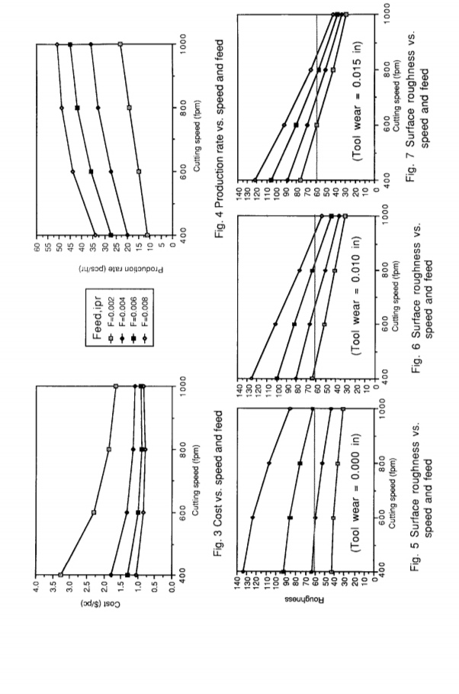
Fig.5:Adjustment of cutting parameters

CHAPTER 8
SUMMARY

The results of this research show that a best solution for the cutting parameters be obtained directly The from the goal programming optimization if the surface roughness specificaiton is not too tight. For a surface roughness specification lessthan106microinches (2.692 micrometers), adjustment away increasing levels of tool wear.
Additional work is needed to incorporate the surface roughness constraint directly the constraint set for the optimization. However, an adequate description of the surface roughness can not be represented in a form that can be linearized, so a different solution methodology from the optimal solution must be made. The optimal solution does provide a good starting point from which changes of feed and speed that will satisfy the surface roughness requirement can be determined. Using the surface roughness model obtained for gray cast iron, further flexibility in the choices of cutting parameters is permitted with will have to be found. When an integrated methodology is and combined with developments in size control algorithms and tool wear estimation, it will be possible to build the cutting parameter correction methodology
directly
CHAPTER 9
REFERENCES

1.Dontamsetti, Satya and Fischer, G.W., "Factors Affecting Surface Roughness in Finish Turning of Gray Cast Iron", Advanced Matedats and Manafacturina
Processes. Vol. 4 no. 4, 1988.
2.Armarego, E.J.A, and Brown, R.H., The M~.¢hinina of Metals. Prentice Hall,
Englewood Cliffs, N.J., 1969.
3.Thomas, T.R., "Characterization of Surface Roughness,', Precision Enaineerin
4 ASME, Surface Texture ISurface Rouahness. Waviness. and Lay), ANSI/ASME
B46.1-1985, ASME, New York, 1986.-
5.Vajpayee, S., "Analytical Study of Surface Roughness in Turning", Wear, Vol. 70
no. 2, 1981.
6.Wallbank, J., "Surfaces Generated in Single-Point Turning", Wear, Vol. 57 no. 2,
1979.
7.Lee, Sang M., Goal Programming for 0ecisign Analysis, Auerbach Publishers Inc.,
Philadelphia, PA, 1972.
8.Groover, M.P. and Zimmers, E.W., CAD/CAM: Comouter-Aided Design and
Manufacturing, Prentice Hall, Englewood Cliffs, N.J, 1984.
9.Machinabilitv Data Svstem for Turnina and Drillina - UsedProgrammer Manual,
Contract No. DC 870160, University of Iowa, October 1987.
10.Schrage, Linus, Linear. Inteaer. and Quadratic prggramming with LINDO. The
Scientific Press, Palo Alto, (~A, 1984.
11.Young, R.D., Vorburger, T.V., Teague, E.C., "In-Process and On-Line Measurement
of Surface Finish", Annals of CIRP, Vol. 29 no. 1, 1980.
12.Zdeblick, W.J., "An Adaptive Planning Methodology for Machining Operations", SME
Paoer MR82-24~, 1982.

